Mission Statement of the Department.
To nurture computer engineering professionals by offering Dynamic learning environment that encourages problem-solving using emerging technology, National Education Policy aligned evidence-based technical education, fostering ,innovation, research, and industry–institute collaboration & Holistic, ethical and sustainable development for lifelong success.

Session 2026-2027

Vision:Dream of where you want. | Mission: Means to achieve Vision

Program Educational Objectives of the program (PEO): (broad statements that describe the professional and career accomplishments)
PEO1 | Preparation | P: Preparation | Pep-CL abbreviation pronounce as Pep-si-lL easy to recall
PEO2 | Core Competence | E: Environment  (Learning Environment) | Pep-CL abbreviation pronounce as Pep-si-lL easy to recall
PEO3 | Breadth | P: Professionalism | Pep-CL abbreviation pronounce as Pep-si-lL easy to recall
PEO4 | Professionalism | C: Core Competence | Pep-CL abbreviation pronounce as Pep-si-lL easy to recall
PEO5 | Learning  Environment | L: Breadth (Learning in diverse areas) | Pep-CL abbreviation pronounce as Pep-si-lL easy to recall

Program Outcomes (PO): (statements that describe what a student should be able to do and know by the end of a program)
Keywords of POs:
Engineering knowledge,Problem analysis, Design/development of solutions,Conduct Investigations of Complex Problems, Engineering Tool Usage, The Engineer and The World,Ethics, Individual and Collaborative Team work,Communication, Project Management and Finance, Life-Long Learning

PSO Keywords: Cutting edge technologies, Research

“I am an engineer, and I know how to apply engineering knowledge to investigate, analyse and design solutions to complex problems using tools for entire world following all ethics in a collaborative way with proper management skills throughout my life.” to contribute to the development of cutting-edge technologies and Research.

Integrity: I will adhere to the Laboratory Code of Conduct and ethics in its entirety.

Name and Signature of Student and Date
(Signature and Date in Handwritten)

Mission Statement of the Department.
To nurture computer engineering professionals by offering Dynamic learning environment that encourages problem-solving using emerging technology, National Education Policy aligned evidence-based technical education, fostering ,innovation, research, and industry–institute collaboration & Holistic, ethical and sustainable development for lifelong success.

Session | 2026-27 (ODD) | Course Name | Web Technology Lab
Semester | 3 | Course Code | 23CT1301
Roll No | 57 | Name of Student | Prasun Kachhwah

Practical Number | 6
Course Outcome | - Understand various internet technologies.  - Design the web pages using HTML and CSS.  - Implement the XML technology to store the data.  - Develop the interactive web pages using JavaScript.
Aim | JavaScript — Arrays, Objects & Higher-Order Functions
Problem Definition | Build a small Weather App or Movie-Search App that fetches data from ONE public API using fetch()/async-await and renders it dynamically.
Theory  (100 words) | Higher-order functions in JavaScript are functions that accept other functions as arguments or return them, enabling powerful data manipulation patterns. They are fundamental to functional programming in JavaScript, where functions are treated as first-class citizens.  For arrays, built-in higher-order methods allow for concise iteration and transformation without manual loops. Common methods include:  - map(): Creates a new array by applying a callback to each element.  - filter(): Creates a new array with elements that pass a test.  - reduce(): Accumulates array values into a single result.  - forEach(): Executes a function for each element (returns undefined).
Mission Statement of the Department.
To nurture computer engineering professionals by offering Dynamic learning environment that encourages problem-solving using emerging technology, National Education Policy aligned evidence-based technical education, fostering ,innovation, research, and industry–institute collaboration & Holistic, ethical and sustainable development for lifelong success.
● find() & some(): Return the first matching element or a boolean if any element matches.
When working with objects, higher-order functions are often combined with object methods or array utilities. For instance, Object.entries() can convert an object into an array of key-value pairs, allowing the use of array higher-order functions like map() or filter(). Additionally, chaining methods like .filter() followed by .map() allows for extracting specific properties from objects within an array based on conditions.

Procedure and Execution  (100 Words) | Step 1: Create the JavaScript file  Step 2: Create the shopping cart  Step 3: Implement the Add operation  Step 5: Implement product-name extraction  Step 6: Calculate the total price  Step 7: Add a new product  Step 8: Remove a product  Step 9: Display product names and total  Step 10: Execute the program
Procedure and Execution  (100 Words) | Code : Javascript let cart = [  { id: 1, name: "Laptop", price: 50000, quantity: 1 },  { id: 2, name: "Mouse", price: 800, quantity: 2 },  { id: 3, name: "Keyboard", price: 1500, quantity: 1 }  ];  function addToCart(product) { cart.push(product);  } function removeItem(id) { cart = cart.filter(product => product.id !== id);  } function getProductNames() { return cart.map(product => product.name);

Department of Computer Technology
Vision Statement of the Department.
To be a preferred hub for nurturing computer engineering aspirants through innovative, ethical, value-based technical education, impactful research, and industry collaboration, to become successful professionals contributing for the betterment of society.
Mission Statement of the Department.
To nurture computer engineering professionals by offering Dynamic learning environment that encourages problem-solving using emerging technology, National Education Policy aligned evidence-based technical education, fostering ,innovation, research, and industry–institute collaboration & Holistic, ethical and sustainable development for lifelong success.
} function calculateTotal() { return cart.reduce(
(total, product) => total + product.price * product.quantity,0); }

console.log(“Initial Cart:”); console.log(cart); addToCart({
id: 4,
name: “Headphones”, price: 2000, quantity: 1
}); console.log("\nCart after adding Headphones:"); console.log(cart); removeItem(2); console.log("\nCart after removing Mouse:"); console.log(cart); console.log("\nProduct Names:"); console.log(getProductNames()); console.log("\nTotal Price: ₹" + calculateTotal());
Department of Computer Technology
Vision Statement of the Department.
To be a preferred hub for nurturing computer engineering aspirants through innovative, ethical, value-based technical education, impactful research, and industry collaboration, to become successful professionals contributing for the betterment of society.
Mission Statement of the Department.
To nurture computer engineering professionals by offering Dynamic learning environment that encourages problem-solving using emerging technology, National Education Policy aligned evidence-based technical education, fostering ,innovation, research, and industry–institute collaboration & Holistic, ethical and sustainable development for lifelong success.
 | 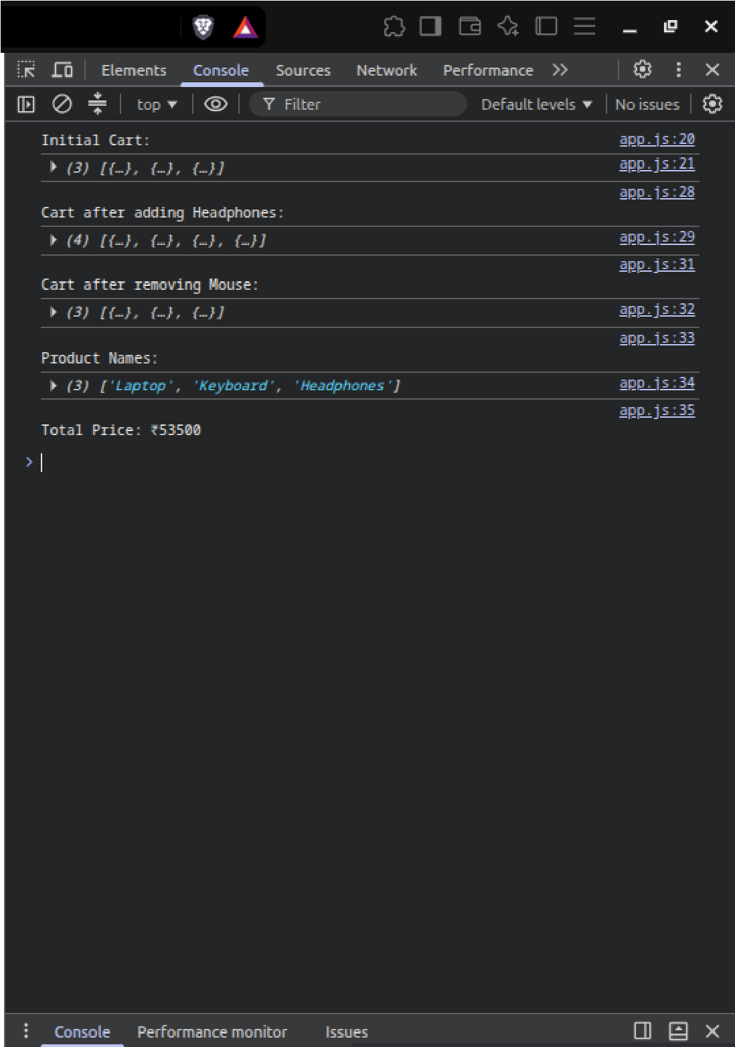
Output Analysis | The JavaScript program successfully models a shopping cart using an array of objects and demonstrates the use of push(), map(), filter(), and reduce() to add products, remove products, retrieve product names, and calculate the total price.
Link of student Github profile where lab assignment has been uploaded | https://github.com/PrasunKachhwah
Conclusion | Successfully studied the arrays and higher order functions of JavaScript and demonstrated built a client side application.
Department of Computer Technology
Vision Statement of the Department.
To be a preferred hub for nurturing computer engineering aspirants through innovative, ethical, value-based technical education, impactful research, and industry collaboration, to become successful professionals contributing for the betterment of society.
Mission Statement of the Department.
To nurture computer engineering professionals by offering Dynamic learning environment that encourages problem-solving using emerging technology, National Education Policy aligned evidence-based technical education, fostering ,innovation, research, and industry–institute collaboration & Holistic, ethical and sustainable development for lifelong success.
Plag Report (Similarity index < 12%) | 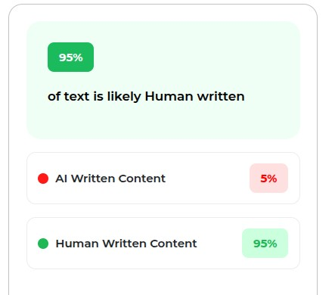
Date | 29/09/2026

